- Virtual ports software, click add ports to add virtual COM port, as following picture, add COM 1 & COM 2 as linked ports
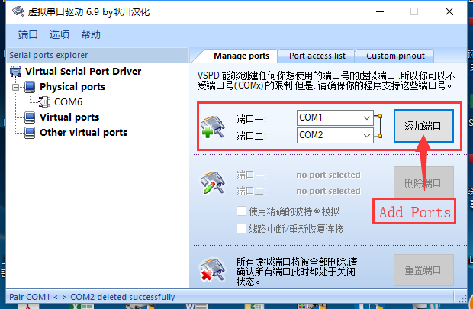
- 125 software setting , here COM3 is for connect the 125 analyzer, COM1 is the virutal COM port for LIS simulator connection.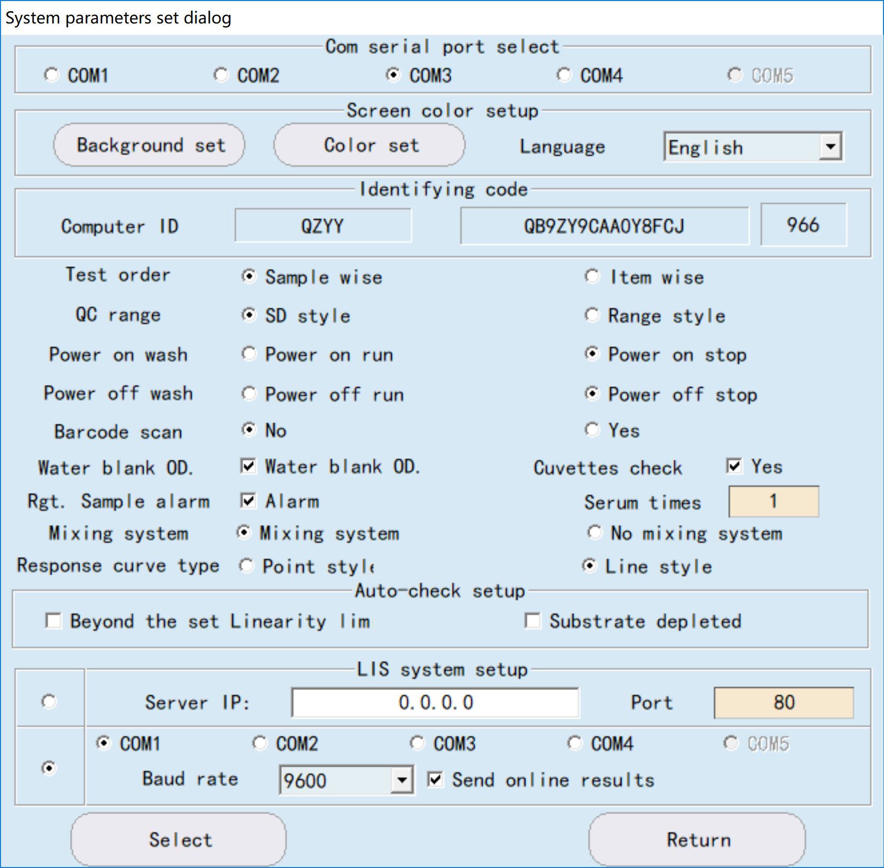
- The 125 should have following test items:
BUN, CREA, GLUC, CREA, URIC, CHOL, TG, HDL, LDL, TP, ALB, TB, DB, AST, ALT, ALP

The sample informaiton in the simulator:
Barcode: 112233, test list: BUN, CREA, GLUC
Barcode: 445566, Test List: GLUC, BUN, CREA, URIC, CHOL, TG, HDL, LDL, TP, ALB, TB, DB, AST, ALT, ALP

- the LIS interface simulator software: Open project file: PKL125-3.ptp
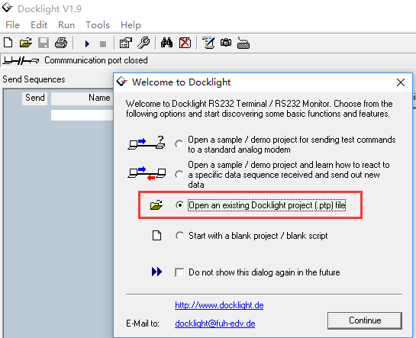
In the Project setting, select the COM 2 for communication, then click Start Communication
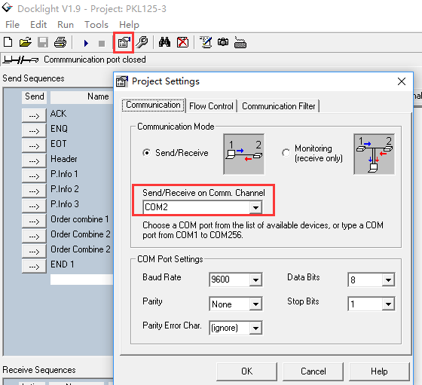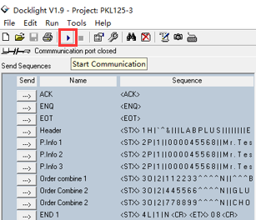

- in the 125 software:
SCHEDULE---> LIS
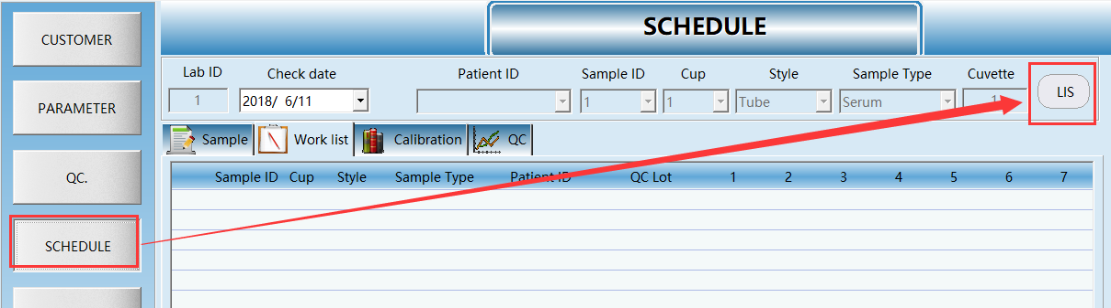
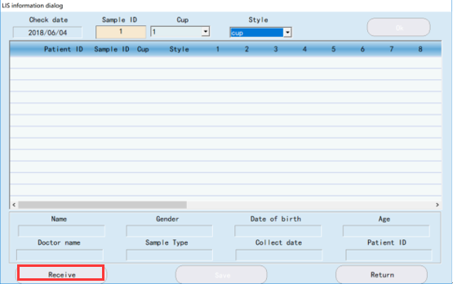
Click the Receive button, then input the PID:112233, click Save , then Receive
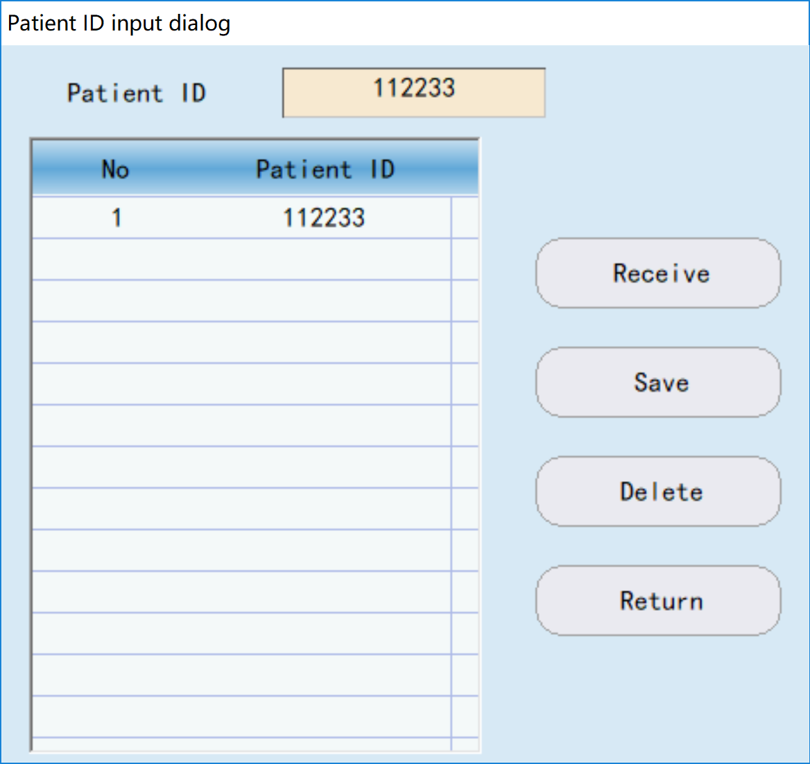
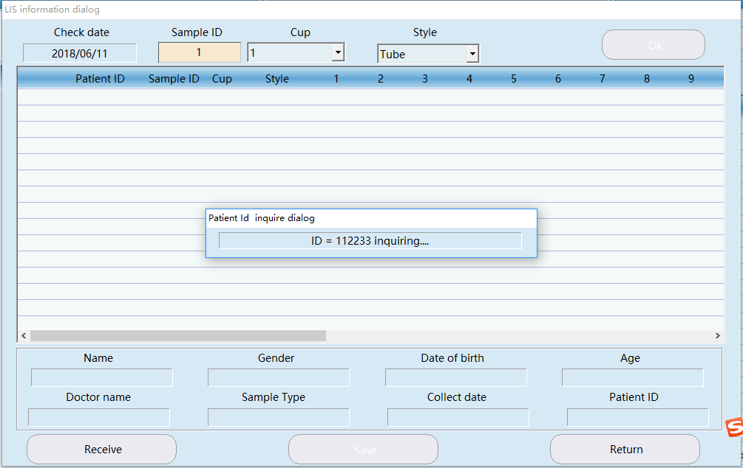

- in the simulation software:

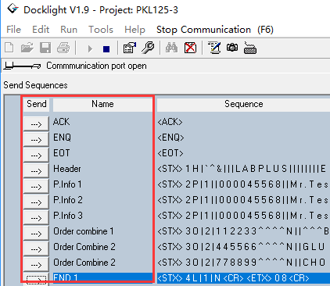
Click the [Send] in following sequent
ACK Header P.Info 1 Order Combin 1 EOT END 1

- in the 125 softare, will receive a PID:112233 test list, as following
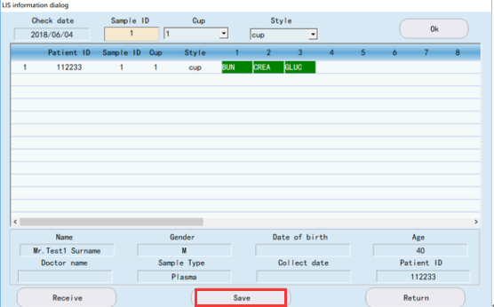
Click Save to save this PID to the working list of 125.

The Steps above simulate download a PID:112233 test list from a server, and all the communication is record in the simulator software, that will help to develop a Lis interface.
